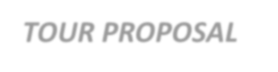 ***TOUR PROPOSAL***

|  |  |
| --- | --- |
| **Name of the client** | **C&K 12D/11N – EAST EUROPE PROMO 2019** |
| **Nationality** | **Indonesian** |
| **Date of proposal** | **March, 2018** |
| **Name of the Group** | **C&K 12D/11N – EAST EUROPE PROMO 2019** |
| **Tentative Travel date** | **Winter & Summer rates 2019** |

# 

**WINTER RATES (NOV-EARLY DEC 2019) :**

|  |  |  |
| --- | --- | --- |
| **SLAB** | **FOC** | **Twin/Dbl Sharing**  **(per person)** |
| **15-19 PAX** | **01 free in single** | **€ 940** |
| **20-24 PAX** | **01 free in single** | **€ 805** |
| **25-29 PAX** | **01 free in single** | **€ 740** |
| **30-34 PAX** | **01 free in single** | **€ 695** |
| **35-39 PAX** | **01 free in single** | **€ 665** |
| **40-44 PAX** | **01 free in single** | **€ 645** |
| **Single Supplement** |  | **€ 285** |

* **ITINERARY**

*Slab pricing is based on Full Paying Adults*

|  |  |  |
| --- | --- | --- |
| **Day 01** | **ARRIVAL BUDAPEST (-/D)** | **(Heroes Square)** |
|  | Pick up at The Airport  **Entrance :** Fisherman’s Bastion, St. Matthias Church  Budapest orientation tour. Pass by / Photostop : Gellért Hill, Synagogue of Dohány Street, Amusement Park, Széchenyi Spa, Heroes’ Square, Andrássy Avene, Opera, St. Stephen’s Basilica, Parliament Building  Dinner at Restaurant  Transfer to Hotel. Overnight at Budapest |  |

# Day 02 BUDAPEST – BANSKA BYSTRICA – KRAKOW (B/-/D)

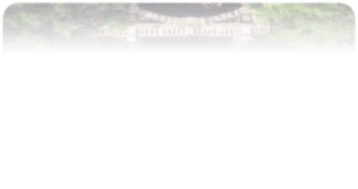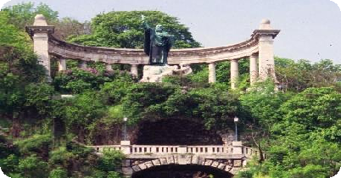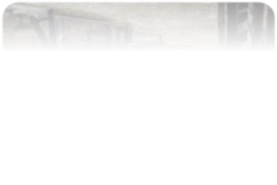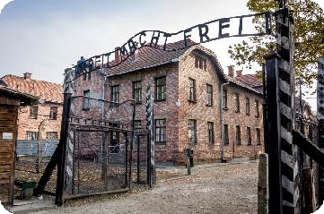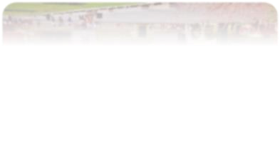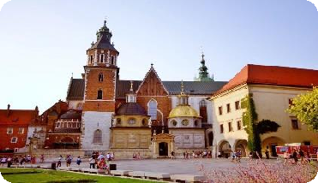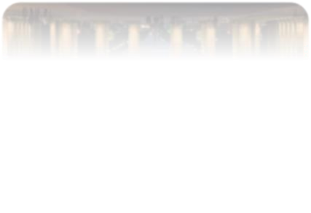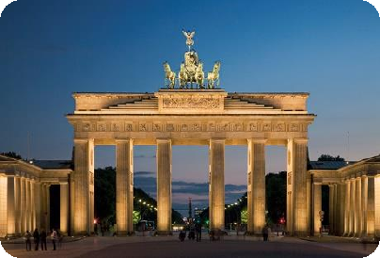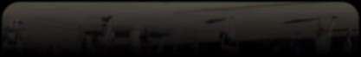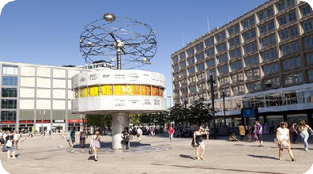

**(Auschwitz Concentration**

**Camp)**

**(Wawel Castle)**

**(Bradenburg Gate)**

**(Alexanderplatz)**

Breakfast at The Hotel Transfer to Banska Bystrica Transfer to Krakow

Dinner at Restaurant

Transfer to Hotel. Overnight at Krakow

# Day 03 KRAKOW (B/-/D)

Breakfast at The Hotel

**Entrance :** Auschwitz Concentration Camp (Guided Tour)

Photostop at Wawel Castle

Free time shopping at Krakow Cloth Hall Dinner at Restaurant

Transfer to Hotel. Overnight at Krakow

# Day 04 KRAKOW – WROCLAW – BERLIN (B/-/D)

Breakfast at The Hotel Transfer to Wroclaw Transfer to Berlin

Dinner at Restaurant

Transfer to Hotel. Overnight at Berlin

# Day 05 BERLIN (B/-/D)

Breakfast at The Hotel

Berlin orientation tour. Pass by / Photostop : Bradenburg Gate, Berlin Wall, Checkpoint Charlie, Reichstag Building, Gendarmenmarkt Square, Alexanderplatz

Free time shopping at KaDeWe Dinner at Restaurant

Transfer to Hotel. Overnight at Berlin

# Day 06 BERLIN – DRESDEN – PRAGUE (B/-/D)

Breakfast at The Hotel Transfer to Dresden Transfer to Prague

Dinner at Restaurant

Transfer to Hotel. Overnight at Prague

# (Gellért Hill)

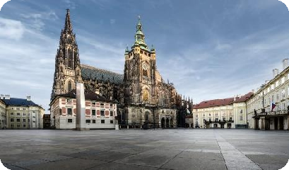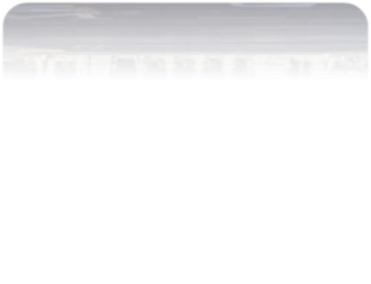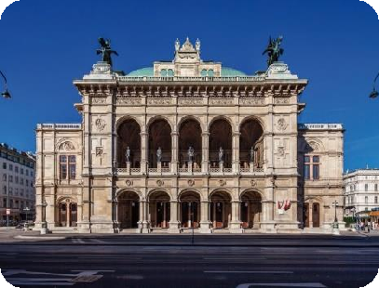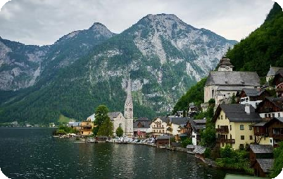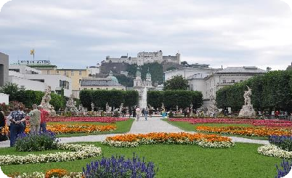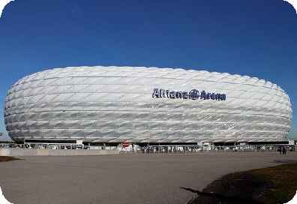

|  |  |  |
| --- | --- | --- |
| **Day 07** | **PRAGUE (B/-/D)** | **(Prague Castle)** |
|  | Breakfast at The Hotel  **Half Day English Speaking Guide**  **Entrance :** Prague Castle – Circuit B |  |
|  | Prague orientation tour. Pass by / Photostop : |  |
|  | Charles Bridge, Astronomical Clock, Old Town |  |
|  | Dinner at Restaurant |  |
|  | Transfer to Hotel. Overnight at Prague |  |
| **Day 08** | **PRAGUE – VIENNA (B/-/D)** | **(Vienna State Opera)** |
|  | Breakfast at The Hotel |  |
|  | Transfer to Vienna |  |
|  | Vienna orientation tour. Pass by / Photostop : |  |
|  | Vienna State Opera, St. Stephan’s Cathedral, |  |
|  | Parliament Building, Town Hall, University at Ring |  |
|  | Strasse |  |
|  | Free time shopping at Kartnerstrasse |  |
|  | Dinner at Restaurant |  |
|  | Transfer to Hotel. Overnight at Vienna |  |
| **Day 09** | **VIENNA – HALLSTATT – SALZBURG (B/-/D)** | **(Hallstatt)** |
|  | Breakfast at The hotel |  |
|  | Transfer to Hallstatt |  |
|  | Hallstatt orientation tour |  |
|  | Transfer to Salzburg |  |
|  | Dinner at Restaurant |  |
|  | Transfer to Hotel. Overnight at Salzburg |  |
| **Day 10** | **SALZBURG – MUNICH (B/-/D)** | **(Mirabell Garden)** |
|  | Breakfast at The Hotel |  |
|  | Salzburg orientation tour. Pass by / Photostop : |  |
|  | Mozart’s Birthplace, Mirabell Garden |  |
|  | Free time shopping at Getreidegasse |  |
|  | Transfer to Munich |  |
|  | Dinner at Restaurant |  |
|  | Transfer to Hotel. Overnight at Munich |  |
| **Day 11** | **MUNICH (B/-/D)** | **(Allianz Arena)** |
|  | Breakfast at The Hotel |  |
|  | Munich orientation tour. Pass by / Photostop : |  |
|  | Allianz Arena, Olympic Stadium, New Town Hall, |  |
|  | Old Town Hall |  |
|  | Free time shopping at Marienplatz |  |
|  | Dinner at Restaurant |  |
|  | Transfer to Hotel. Overnight at Munich |  |

**Day 12 MUNICH – DEPARTURE (B) (Munich)**

Breakfast at The Hotel

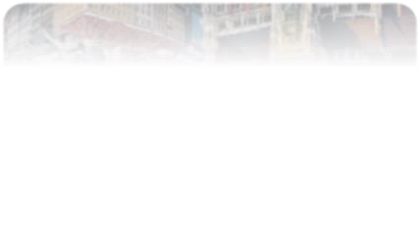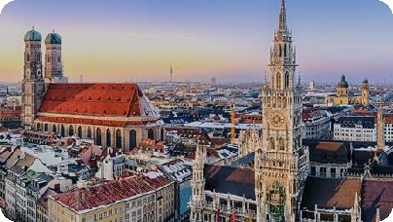

One way transfer from Hotel to Airport End of services

# Hotel –

|  |  |  |  |
| --- | --- | --- | --- |
| **Hotel Name** | **City** | **Rating** | **No . Of Nights** |
| Hotel Aquamarine or similar | **Budapest** | 4* | 01 |
| Quality System Hotel or similar | **Krakow** | 3* | 02 |
| Pentahotel Berlin-Potsdam or similar | **Berlin** | 4* | 02 |
| Best Western Amedia or similar | **Prague** | 3* | 02 |
| Simm’s Hotel or similar | **Vienna** | 4* | 01 |
| Austria Trend Mitte or similar | **Salzburg** | 3* | 01 |
| Mercure Orbis or similar | **Munich** | 4* | 02 |

* **Package Inclusions**
* 11 Nights accommodation at Hotels specified in the itinerary or similar.
* 11 Buffet Breakfasts.
* 11 Dinner ( No Pork / 3 Course Local / 5 Dish Chinese menu )

# Service of Long Distance coach as per the flow of itinerary

* FOC as per the slab.

# Package Exclusions :

* Early Check In and Late Check Out charges.
* Optional and Add-on tours unless mentioned otherwise.
* Porterage at The Airport
* Any High Season Surcharges / Peak Season Supplements etc.
* Any Airfare
* Visas
* Travel Insurance
* City taxes at the hotels
* Mandatory tips to coach drivers, guides & discretionary tips to waiters or any other local services.
* Anything not specifically mentioned in the “Tour Price Includes” column.

**Child Policy :** Infant ( 0-2.99 yrs) FREE

* + Child (3-7 yrs ) sharing room with 02 full paying adults without extra bed 55% of adult cost.
  + Child (8-11 yrs) sharing room with 02 full paying adults with bed 70% of adult cost.
  + Child (12-16 yrs) will be treated as an adult sharing room on triple occupancy depending upon Hotel policy.

# Important Notes : -

* Rates are valid for 72 hours
* Rates are nett and non - commissionable
* Rates do not include surcharges applicable during Trade Fairs / Peak Season / Public Holidays

/ Festivals.

* Hotels, rooms and services are subject to availability at the time of booking.
* **Standard Check In time for Hotels:** 1400 Hrs & **Check Out time:** 1100 Hrs
* Kindly note the quote is not valid during black out dates/fair period**.** During this time we reserve the right to charge a supplement and/or offer hotel outside the city limits.
* We may arrange the meal at hotel or restaurants .